**Project Design Phase**

**Problem – Solution Fit Template**

|  |  |
| --- | --- |
| Date | 28 June 2025 |
| Team ID | LTVIP2025TMID35624 |
| Project Name | Revolutionizing Liver Care: Predicting Liver Cirrhosis Using Advanced Machine Learning Techniques |
| Maximum Marks | 2 Marks |

**Problem – Solution :**

We propose building a machine learning (ML)–based predictive model to detect liver cirrhosis in its early stages using non-invasive, routinely available clinical and laboratory data. The model will assist in identifying high-risk individuals and support early diagnosis and proactive intervention.

1. **Data Source:**

Source: <https://www.kaggle.com/datasets/bhavanipriya222/liver-cirrhosis-prediction>

Description: This dataset includes structured, anonymized patient records featuring:

* **Demographics**: Age, Gender, Location
* **Medical History**: Alcohol consumption, Hepatitis infections, Diabetes
* **Laboratory Tests**: Blood counts, liver function tests, lipid profiles
* **Clinical Indicators**: Blood pressure, obesity status, family history

**2. Solution Workflow**

1. Data Collection & Preprocessing

* Perform preprocessing steps such as:
  + Handling missing values
  + Encoding categorical variables (e.g., gender, yes/no lifestyle factors)
  + Normalizing continuous features
  + Feature selection to retain only the most relevant attributes
* Data Exploration and Preprocessing
* Univariate Analysis: Histograms were plotted for numerical features.
* Bivariate Analysis: Scatter plots and pair plots explored relationships between features.
* Outlier Handling: Outliers were detected and managed using the IQR method.

2. Model Development

* Train and evaluate multiple machine learning algorithms, including:
  + Random Forest
  + Naïve Bayes
  + XG Boost
  + Logistic Regression CV
  + Random Forest
  + Support Vector Classifier
  + Ridge Classifier
  + Logistic Regression
  + K-Nearest Neighbors (KNN)
* Apply cross-validation and hyperparameter tuning to optimize performance.
* Use evaluation metrics: Accuracy, Precision, Recall, F1-score, and Confusion Matrix to validate the models.

3.Model Selection  
 We will select and optimize the best model based on performance metrics to achieve the highest accuracy.

4.Prediction

* Generate predictions in the form of: Binary classification (Cirrhosis: Yes/No)

5. Interface Design

* Building a user-friendly web or mobile platform using tools like: HTML/ CSS +JavaScript(Frontend),Flask (Backend)
* Users can input lab results and receive the Prediction results.

**Template:**

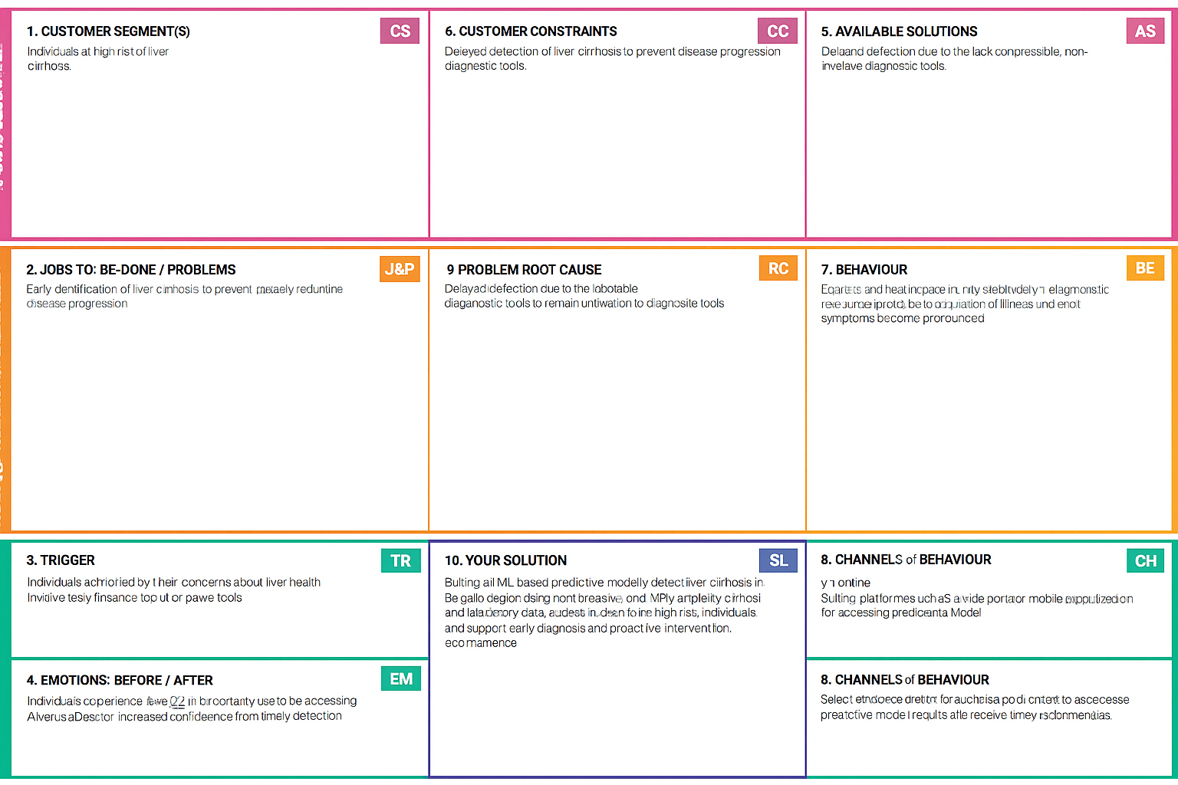

References:

1. <https://www.ideahackers.network/problem-solution-fit-canvas/>
2. <https://medium.com/@epicantus/problem-solution-fit-canvas-aa3dd59cb4fe>